API Documentation IDP Project - Training Application – Muhamad Ramdan Nugraha

1. A.1. Register POST /api/user-register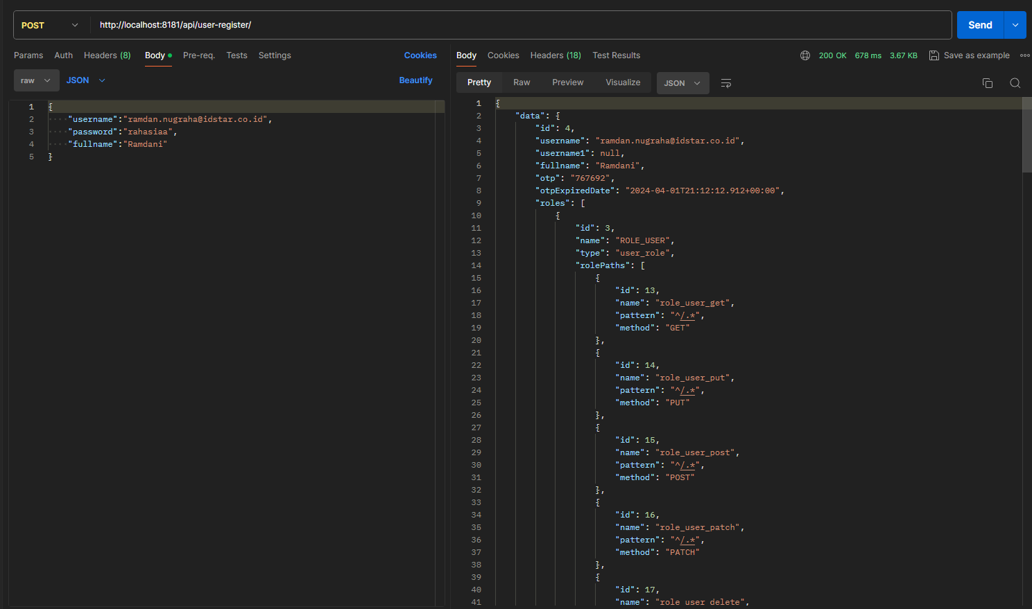

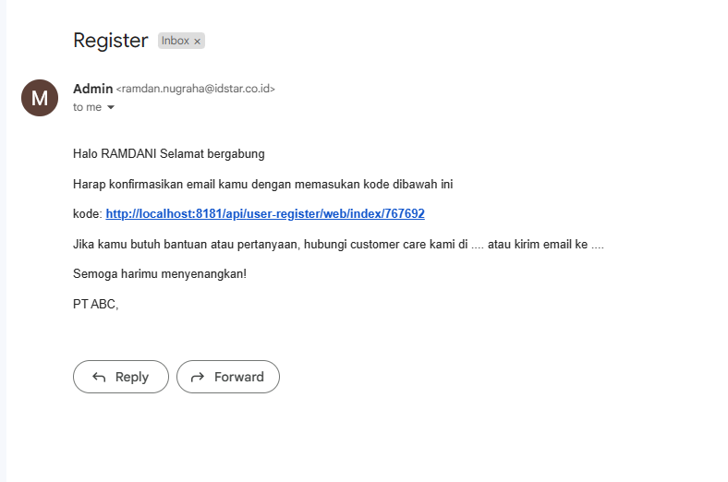

2. A.2. Send-OTP Email : digunakan saat register POST /api/user-register/send-otp  
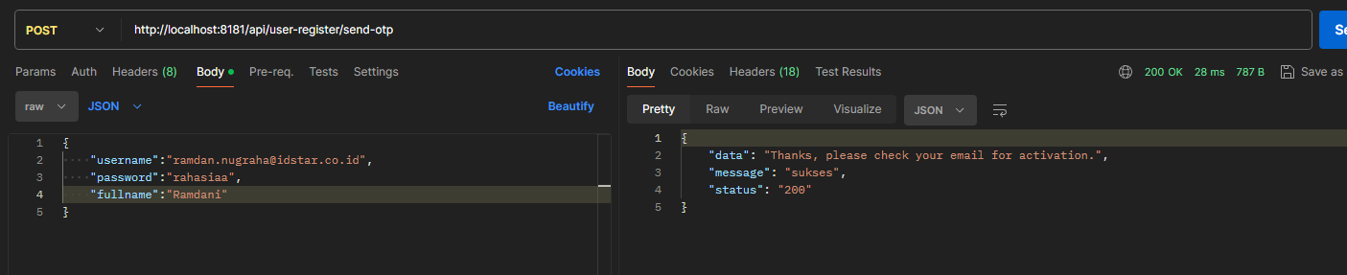

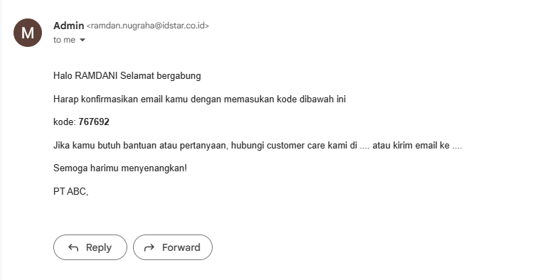

GET /api/user-register/register-confirm-otp/7673849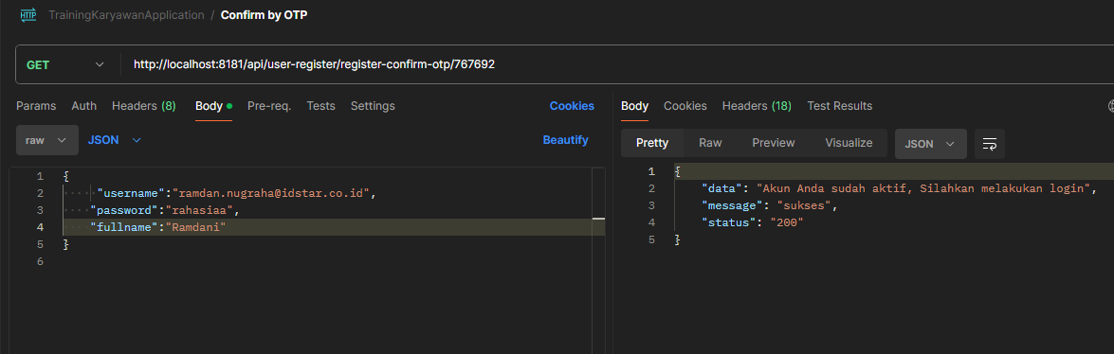

B.1. Login POST /api/user-login/login  
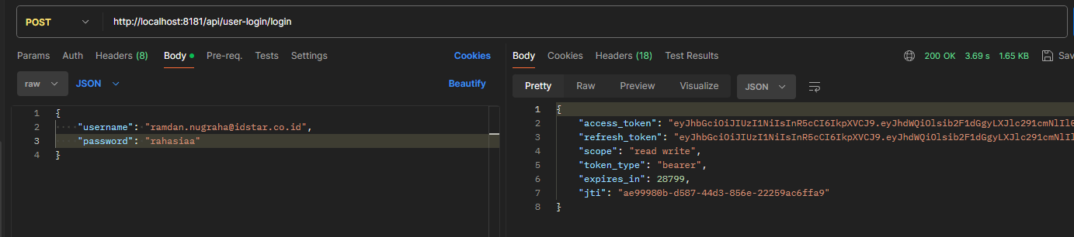

C.1. Forget Password – Send Email POST /api/forget-password/send  
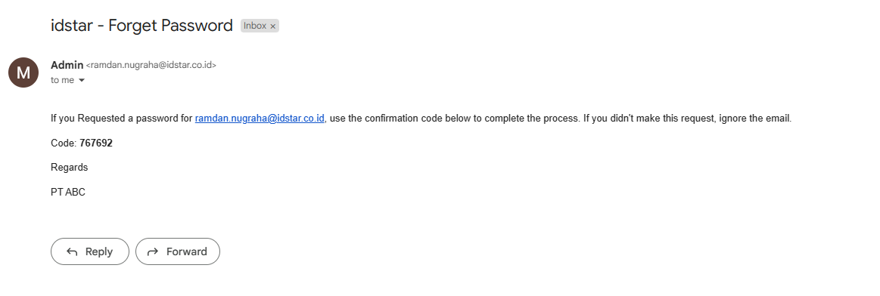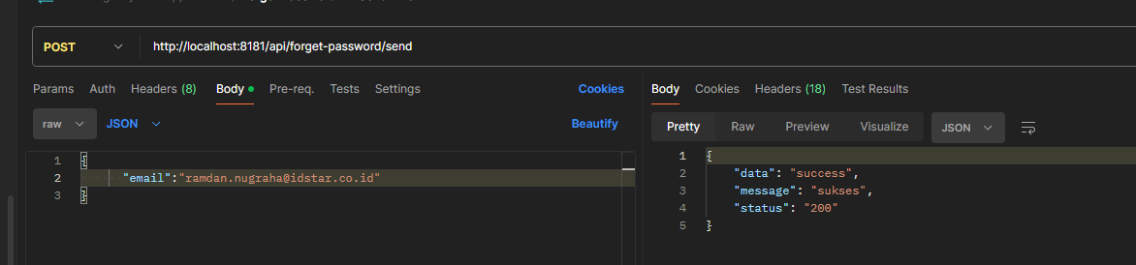

C.2. Forget Password – Validate by OTP POST /api/forget-password/validate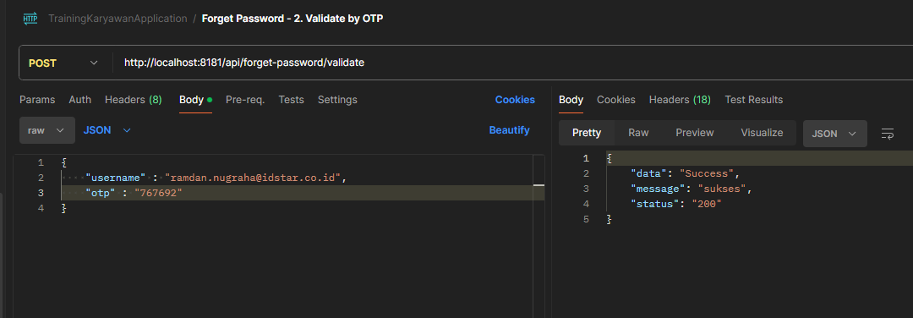

C.3. Forget Password – Change Password POST /api/forget-password/change-password

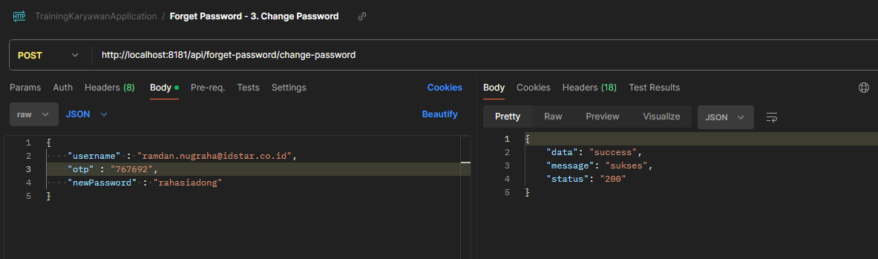

.1. Upload File POST /api/v1/upload

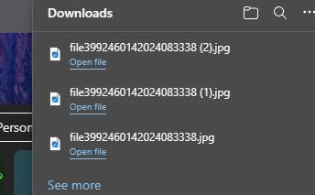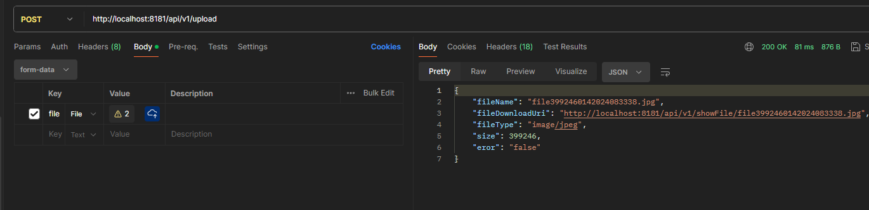

1. Insert Karyawan & Detail POST /api/v1/idstar/karyawan/save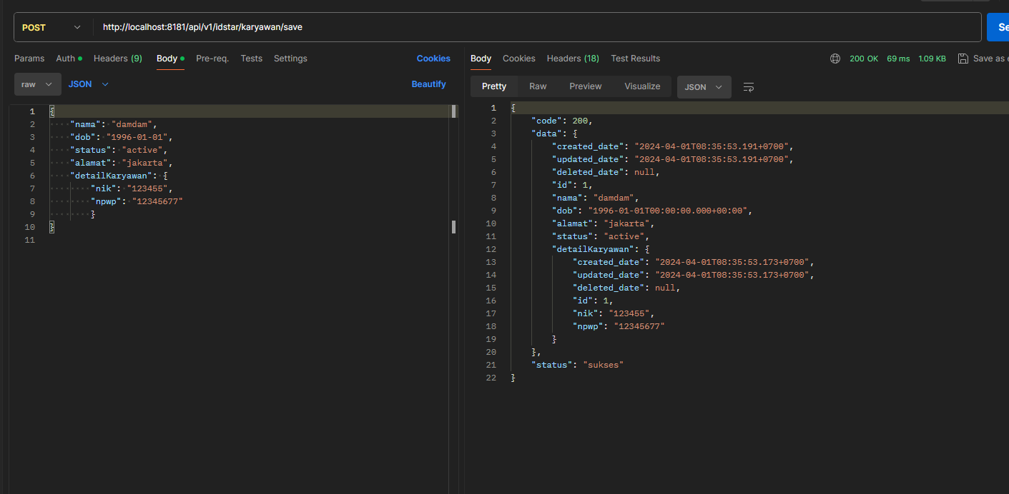
2. 2. Update Karyawan & Detail PUT /api/v1/idstar/karyawan/update

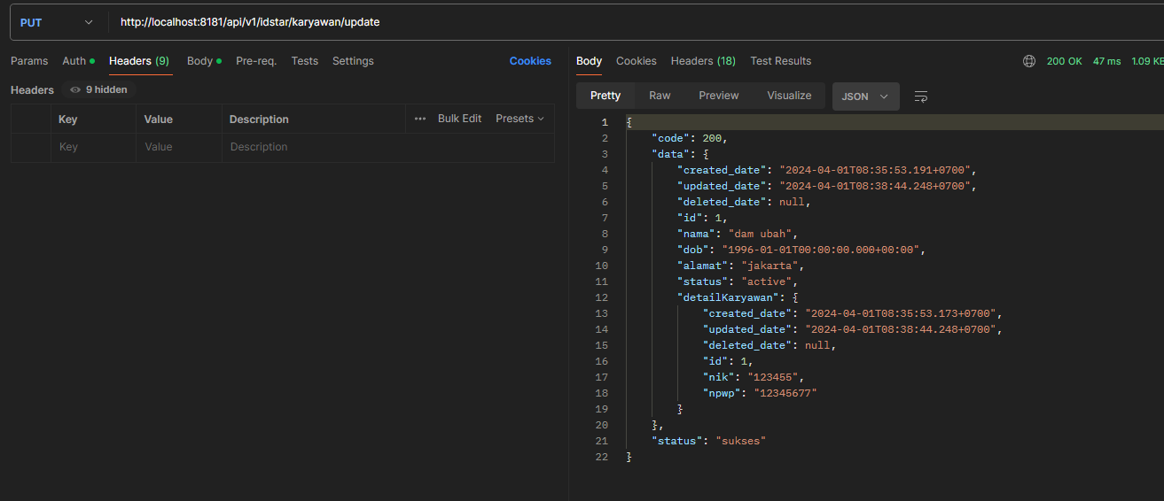

1. Get All Karyawan GET /api/v1/idstar/karyawan/list  
   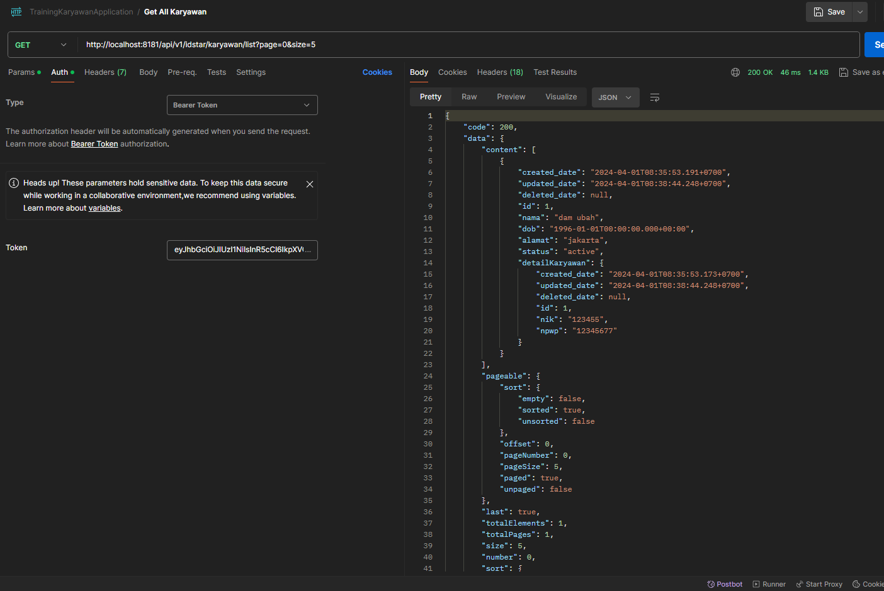
2. Get Karyawan by Id GET /api/v1/idstar/karyawan/{id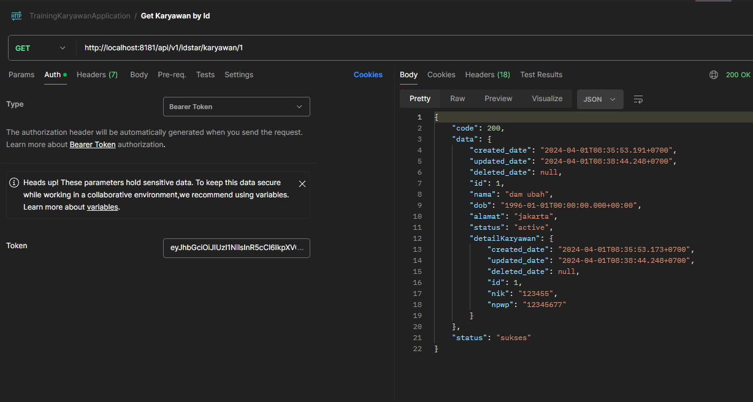
3. DELETE ada di postman collection

6 CRUD Rekening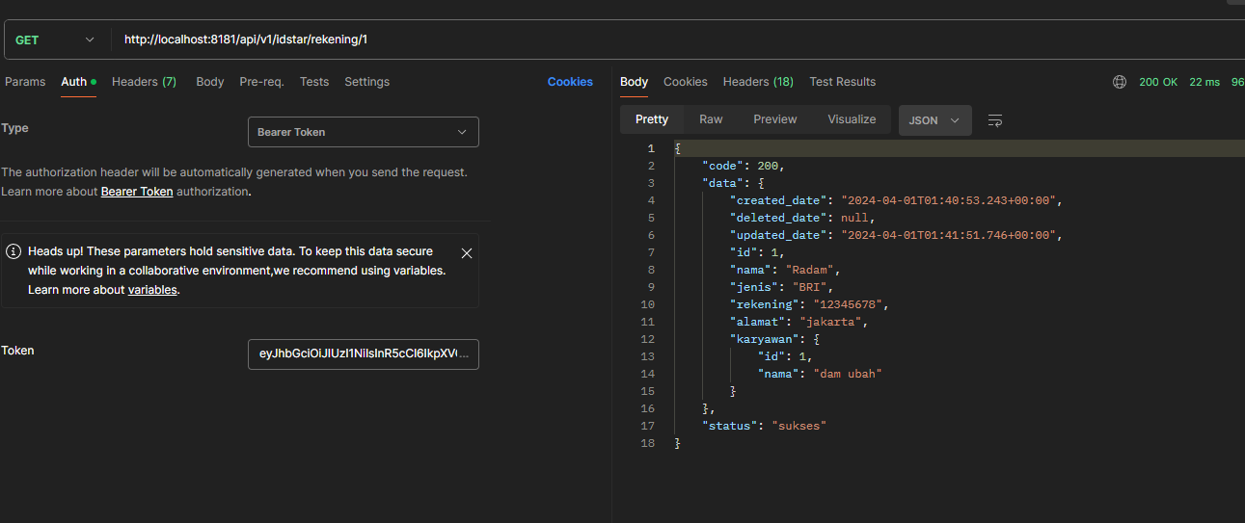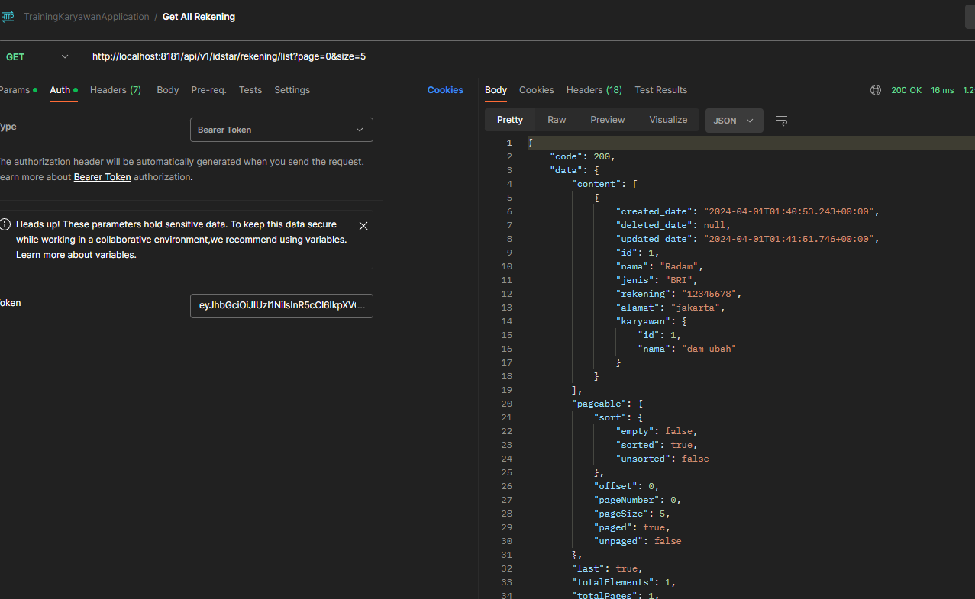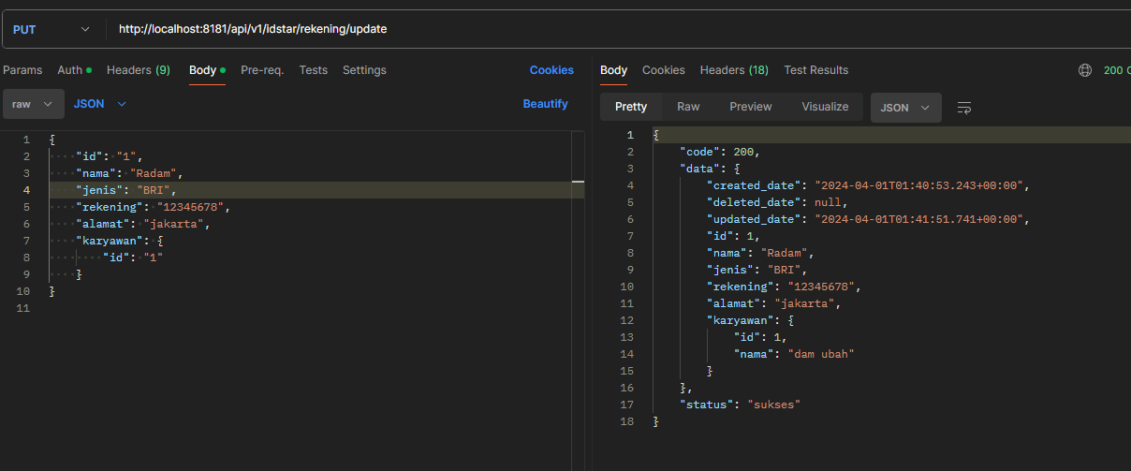 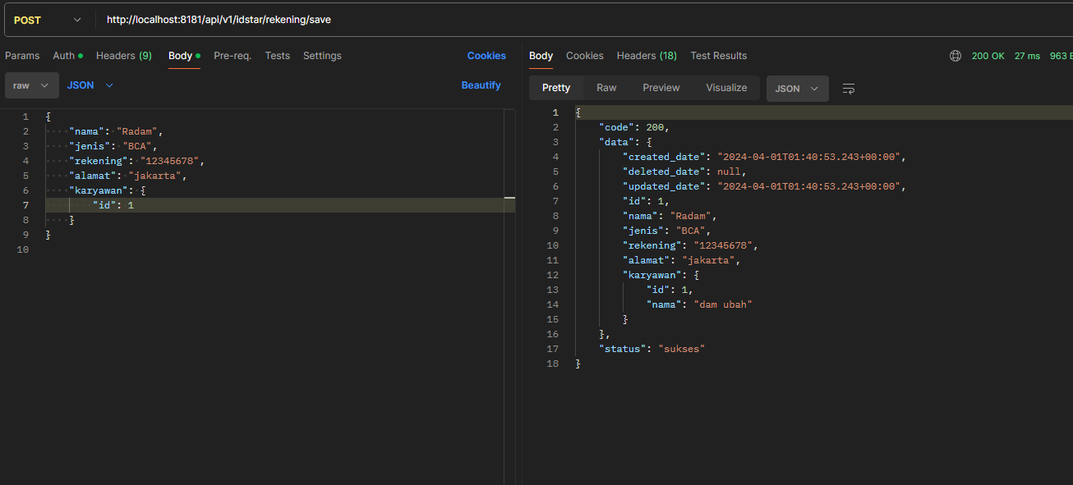

1. CRUD training
2. 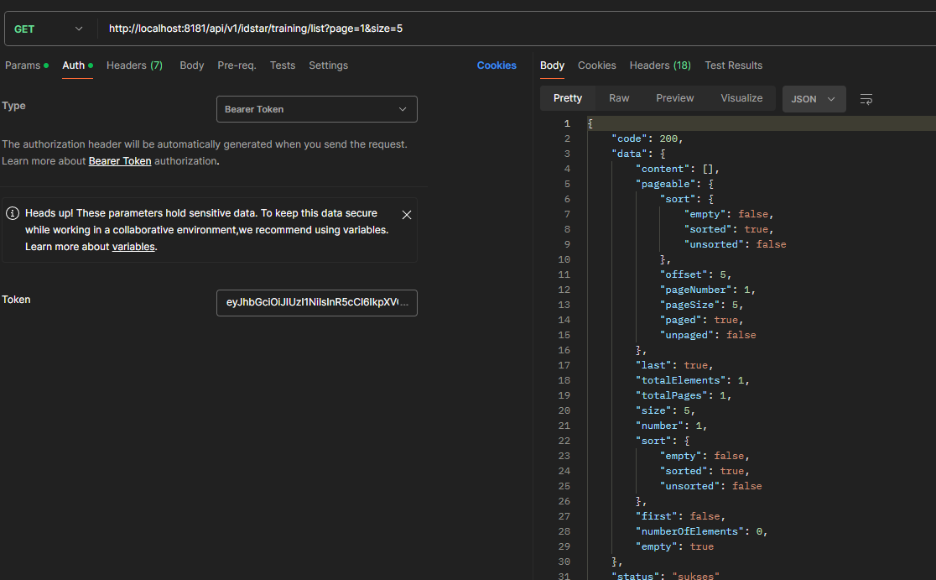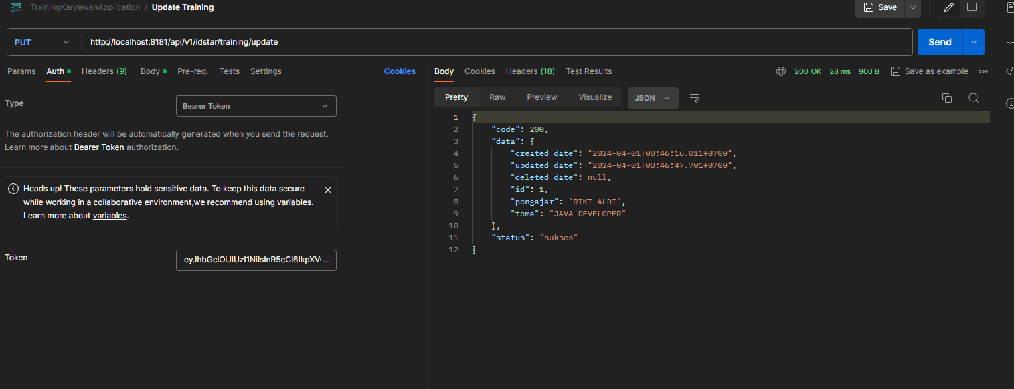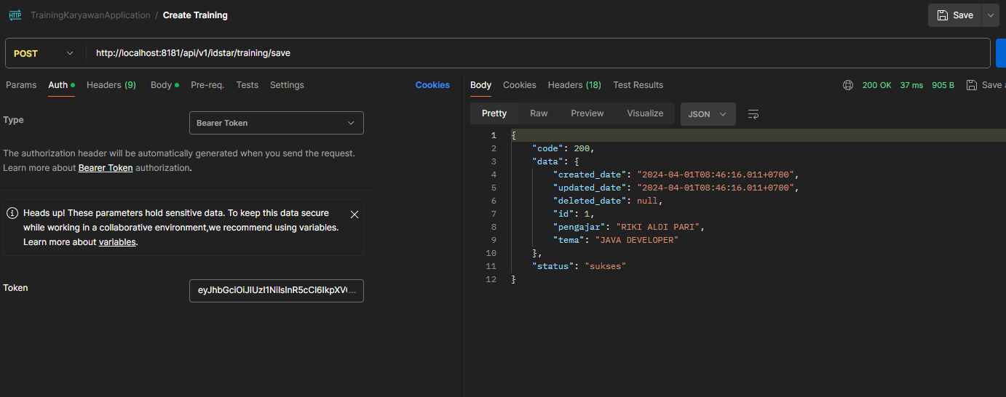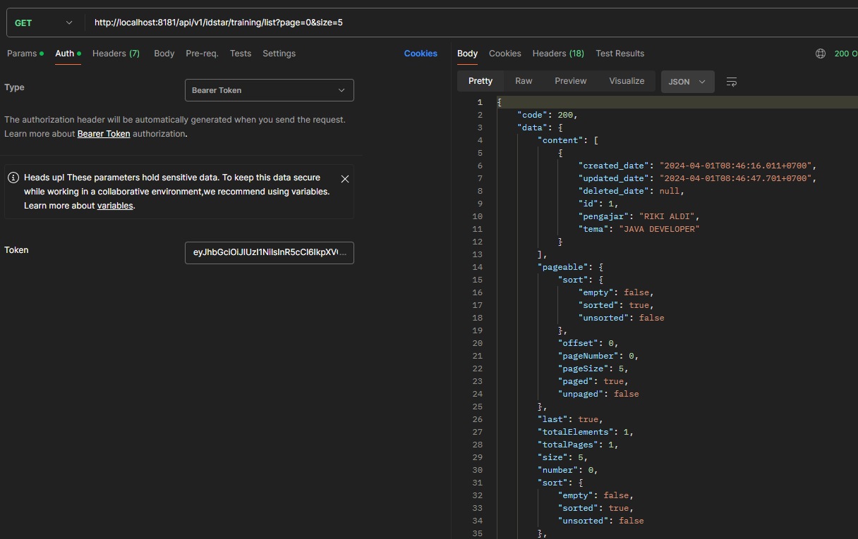
3. CRUD karyawan training
4. 